Tail dependence: AUDUSD and USDJPY
Method 19 / daily log returns / alpha=0.05 / Alpari D1 full available history

Study setup
Logical pair: AUDUSD , USDJPY
Broker symbols: AUDUSD_i , USDJPY_i
Snapshot: 2026-11-03_majors_alpari_D1
Timeframe: D1
Matched return window: 1999-01-05 to 2026-11-02 (UTC bar dates)
Matched return count n: 7199
Dropped unfinished last bar dated 2026-11-03 UTC after a tick-volume check against the prior complete day.
Uniforms: ranks/(n+1); alpha=0.05
Complete matched rows (Excel): AUDUSD-USDJPY_Tail_D1.xlsx
Complete matched rows (HTML table): AUDUSD-USDJPY_Tail_D1_data.html

Method carried forward
Tail dependence counts how often both legs sit in an extreme uniform tail together. Matched daily log returns of close, ln(close_t / close_t-1), become u_i = rank(x_i)/(n+1) and v_i = rank(y_i)/(n+1). At alpha=0.05, lower L_hat = (# u<=alpha and v<=alpha) / (# conditioning leg <= alpha); upper uses >= 1-alpha. Both conditioning directions are reported with numerator and denominator counts. Quotes are not inverted. L_hat(0.05) is a finite-sample frequency, not the asymptotic lambda. Same-sample Pearson r is a side check. This is not causation and not a trading signal.

Results
tail | cond | L_hat | num | denom
lower | USDJPY | 0.169444 | 61 | 360
lower | AUDUSD | 0.169444 | 61 | 360
upper | USDJPY | 0.097222 | 35 | 360
upper | AUDUSD | 0.097222 | 35 | 360
Pearson r on returns: -0.088151

Conclusion
Over 7199 matched daily rows for AUDUSD and USDJPY at alpha=0.05, lower L_hat conditioning on USDJPY is 0.1694 (61/360); conditioning on AUDUSD is 0.1694. Upper L_hat conditioning on USDJPY is 0.0972; on AUDUSD is 0.0972. Pearson r = -0.0882. These are finite-sample frequencies, not asymptotic lambda and not a trading signal.

Charts
Daily closes

Daily log returns

Uniforms with alpha lines
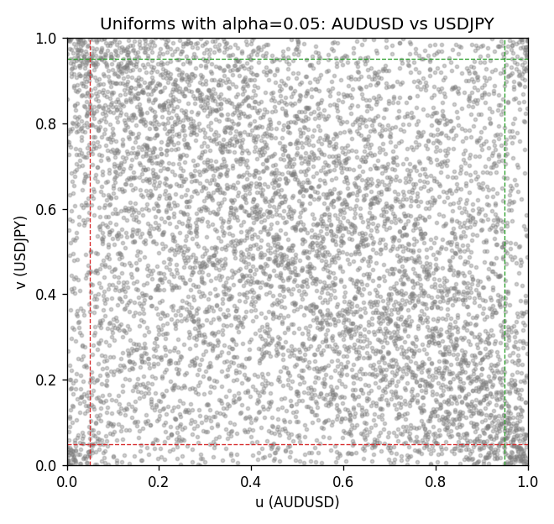

Data report
Every matched row is stored in the sibling Excel workbook named AUDUSD-USDJPY_Tail_D1.xlsx, including u and v. Embedding all rows as a Word table is impractical; this file holds column summaries and the first and last 15 matched rows.
Columns: time, AUDUSD_open, USDJPY_open, AUDUSD_high, USDJPY_high, AUDUSD_low, USDJPY_low, AUDUSD_close, USDJPY_close, AUDUSD_tick_volume, USDJPY_tick_volume, AUDUSD_spread, USDJPY_spread, AUDUSD_real_volume, USDJPY_real_volume, AUDUSD_log_return, USDJPY_log_return, u, v
Column summaries (matched calculation rows)
column | count | mean | std | min | 25% | 50% | 75% | max
AUDUSD_open | 7199 | 0.75196998 | 0.13527571 | 0.4785 | 0.661035 | 0.73142 | 0.809135 | 1.10284
USDJPY_open | 7199 | 113.81114 | 19.206896 | 75.693 | 104.4285 | 110.984 | 120.6925 | 163.824
AUDUSD_high | 7199 | 0.75602148 | 0.13583632 | 0.4878 | 0.6647 | 0.7349 | 0.815325 | 1.10795
USDJPY_high | 7199 | 114.30872 | 19.268446 | 76.001 | 104.881 | 111.442 | 121.26 | 163.978
AUDUSD_low | 7199 | 0.7479145 | 0.13459018 | 0.4775 | 0.6577 | 0.72758 | 0.80425 | 1.0975
USDJPY_low | 7199 | 113.28779 | 19.134887 | 75.402 | 103.89 | 110.53 | 120.17 | 163.628
AUDUSD_close | 7199 | 0.75202255 | 0.13525884 | 0.4786 | 0.661195 | 0.73175 | 0.809235 | 1.10169
USDJPY_close | 7199 | 113.824 | 19.222288 | 75.811 | 104.42 | 111.025 | 120.687 | 163.851
AUDUSD_tick_volume | 7199 | 77366.826 | 138149.99 | 109 | 5440 | 43349 | 71344.5 | 1234623
USDJPY_tick_volume | 7199 | 106151.62 | 179316.41 | 197 | 9927 | 53098 | 92761 | 1803508
AUDUSD_spread | 7199 | 30.814558 | 16.886804 | 0 | 13 | 30 | 50 | 50
USDJPY_spread | 7199 | 20.321434 | 17.631726 | 0 | 6 | 11 | 30 | 50
AUDUSD_real_volume | 7199 | 5.2435469e+09 | 1.2539788e+11 | 0 | 0 | 0 | 0 | 3.811512e+12
USDJPY_real_volume | 7199 | 3.470603e+10 | 1.6078743e+11 | 0 | 0 | 0 | 0 | 3.8834203e+12
AUDUSD_log_return | 7199 | 2.78e-05 | 0.00754502 | -0.08602525 | -0.00385397 | 0.00028846 | 0.00415332 | 0.0806166
USDJPY_log_return | 7199 | 4.761e-05 | 0.00620532 | -0.03908203 | -0.00320306 | 0.00011368 | 0.00340781 | 0.05184024
u | 7199 | 0.5 | 0.28865507 | 0.00013889 | 0.25006944 | 0.5 | 0.74993056 | 0.99986111
v | 7199 | 0.5 | 0.28865508 | 0.00013889 | 0.25006944 | 0.5 | 0.74993056 | 0.99986111
First 15 matched rows (selected columns)
time | AUDUSD_log_return | USDJPY_log_return | u | v
1999-01-05 | -0.00080418179 | -0.00017868311 | 0.43083333 | 0.47138889
1999-01-06 | 0.011836351 | 0.0075660159 | 0.95847222 | 0.91166667
1999-01-07 | 0.0088650256 | -0.012851583 | 0.91694444 | 0.023194444
1999-01-08 | 0.00031515916 | -0.0047719894 | 0.50194444 | 0.16861111
1999-01-11 | 0.0072213815 | -0.016195423 | 0.87763889 | 0.013333333
1999-01-12 | -0.0048608485 | 0.032310364 | 0.20513889 | 0.99958333
1999-01-13 | -0.0078902098 | 0.0081373171 | 0.11111111 | 0.925
1999-01-14 | -0.002696916 | 0 | 0.31152778 | 0.48756944
1999-01-15 | 0.007123101 | 0.0055343401 | 0.87361111 | 0.85166667
1999-01-18 | 0.00094592471 | 8.7600193e-05 | 0.54638889 | 0.4975
1999-01-19 | 0.0072225153 | -0.0056219403 | 0.87777778 | 0.13958333
1999-01-20 | 0.0012507819 | -0.0053879917 | 0.56652778 | 0.14666667
1999-01-21 | 0.00078094498 | 0.0084664056 | 0.53513889 | 0.92958333
1999-01-22 | -0.012252745 | 0.0060412564 | 0.044027778 | 0.86930556
1999-01-25 | -0.0039591468 | -0.0073594164 | 0.24444444 | 0.092361111
Last 15 matched rows (selected columns)
time | AUDUSD_log_return | USDJPY_log_return | u | v
2026-10-13 | 0.0035007712 | -0.0018932826 | 0.71236111 | 0.32805556
2026-10-14 | -0.0015193215 | 7.5800166e-05 | 0.38208333 | 0.49569444
2026-10-15 | -0.0075447063 | -0.0018524319 | 0.11763889 | 0.33097222
2026-10-16 | 0.0033906408 | -0.00037976126 | 0.70652778 | 0.45027778
2026-10-19 | 0.0050859986 | 0.0034946841 | 0.79513889 | 0.755
2026-10-20 | 0.0034620426 | -0.0022546642 | 0.71027778 | 0.30402778
2026-10-21 | 0.0036066384 | -0.00032883504 | 0.71916667 | 0.45625
2026-10-22 | -0.0012672558 | -0.0085942669 | 0.4 | 0.066805556
2026-10-23 | 0.0023765656 | 0.00035080446 | 0.63791667 | 0.52194444
2026-10-26 | -0.0032032829 | 0.0041238746 | 0.28277778 | 0.79152778
2026-10-27 | 0.0016669876 | 0.0027651658 | 0.59069444 | 0.71166667
2026-10-28 | 0.0040915541 | -0.00095679538 | 0.74666667 | 0.39847222
2026-10-29 | -0.0040915541 | -0.00038043789 | 0.23888889 | 0.45013889
2026-10-30 | 0.0010102376 | -0.0010596481 | 0.54958333 | 0.39194444
2026-11-02 | -0.0049184984 | 0.0026438521 | 0.2025 | 0.70347222

